

**Numerical Project**

**Submitted to: Dr. Amani Abdul Qadir Aziz El Gammal**

**Team : 9**

**Members :**

**Jomana Hossam Youssef 1200023**

**Salma Osama Antar Adly 1200474**

**Hanzada Fayez Yehia 1200075**

**Fatema Mohammad 1200908**

**Heba Gamal Hassan Ali 1200076**

**Ahmad Mohsen Tahoon 1170093**

**Nour Eldin Amr Ibrahim 1200450**

**Marly Mofeed Makram 1200909**

**Ziad Abd El Wareth 1200471**

**Peter Ashraf Moussa 1200901**

**Nouran ahmed Mohamed 1180043**

# Introduction

Solving a system of differential equations can be done by a lot of methods like homogenous with constant coefficients, the method of undetermined coefficients, variation of parameters method, Cauchy Euler, reduction of order, and many more. These methods solve the equations exactly, but most second-order ODEs arising in realistic applications cannot be solved exactly. For these problems, one does a qualitative analysis to get a rough idea of the behavior of the solution, then a numerical method is employed to get an accurate solution. In this way, one can verify the answer obtained from the numerical method by comparing it to the answer obtained from qualitative analysis. In a few fortunate cases, a second-order ODE can be solved exactly, and there are a lot of methods to solve with like Euler’s method, Henn’s method, Runge Kutta method, predictor-corrector method, Richard’s extrapolation, Runge Kutta Nystrom. The accuracy of numerical analysis increases by decreasing the step size and increasing the number of iterations in the iterative method; the accuracy of the most frequently used methods of integrating differential equations is fairly well known.

## Numerical Methods and Real-Life Applications

This study will focus on two numerical methods: Runge Kutta and Finite Difference. These methods are used in real-life applications. Runge-Kutta (RK) methods are used widely in many types of research mainly in fluid dynamics and mechanics for better solutions of the fluids. Another real-life application of the Runge-Kutta method is simulation and games. In all present games, we find the motion of objects relatively and vary the position of different objects according to it. If there is only one force acting on the body, or only one acceleration such as gravity, then we can apply simply laws of motion. But, in reality, many constraints change with time or velocity or any other physical quantity. In this type of situation, we need to numerically integrate the equations we have to get the approximation of the moving object.

# Problem 1

# 1) The flow through porous media can be described by the Laplace equation, where h is the head. Use the Finite Difference Method to determine the distribution of heads for the system shown below with the indicated initial and boundary conditions; (Use h=k=0.1)

## Hand Analysis :

We have got 31 unknown so we needed 31 equations FROM BD AND FD.

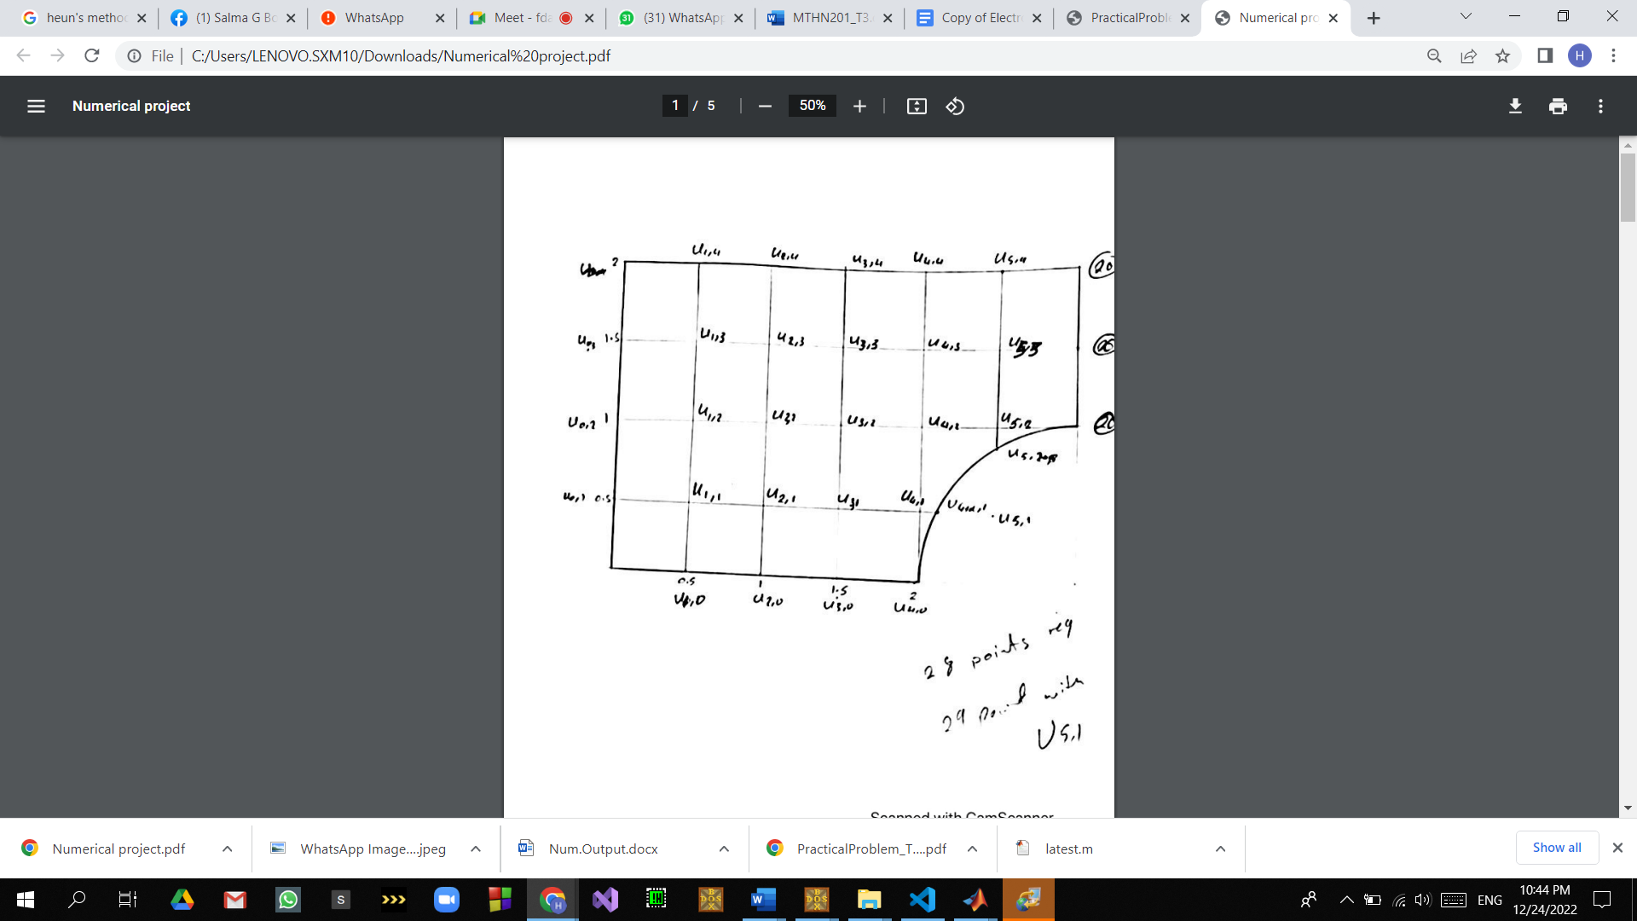

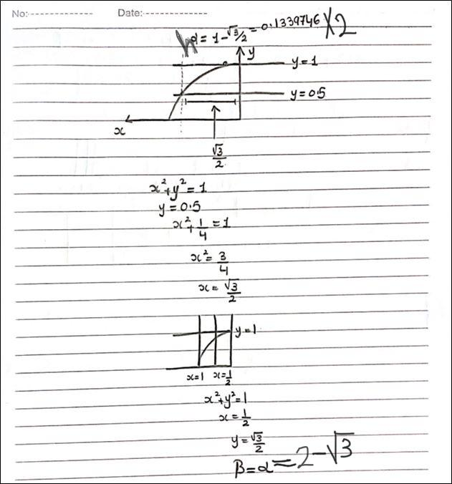

β=α=2-

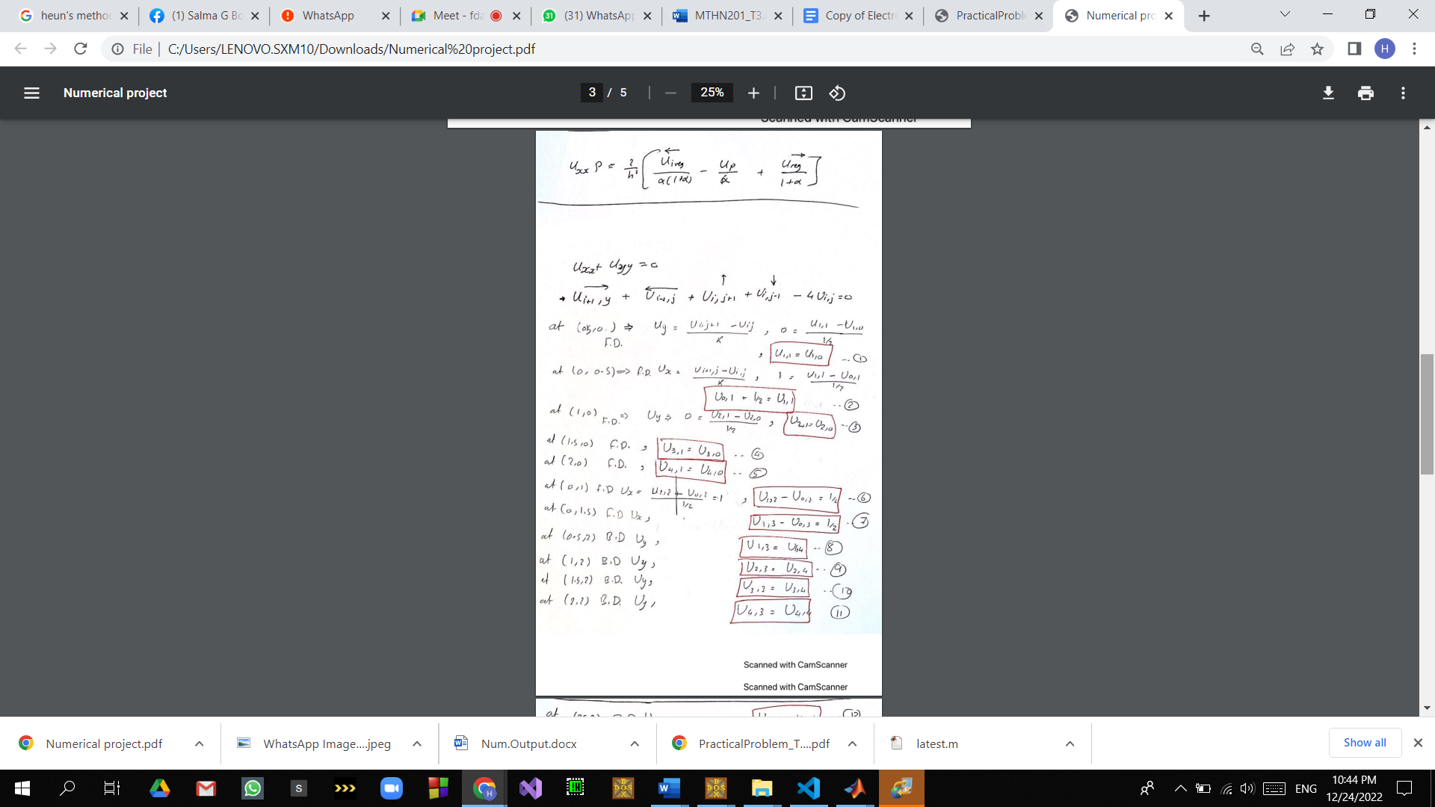

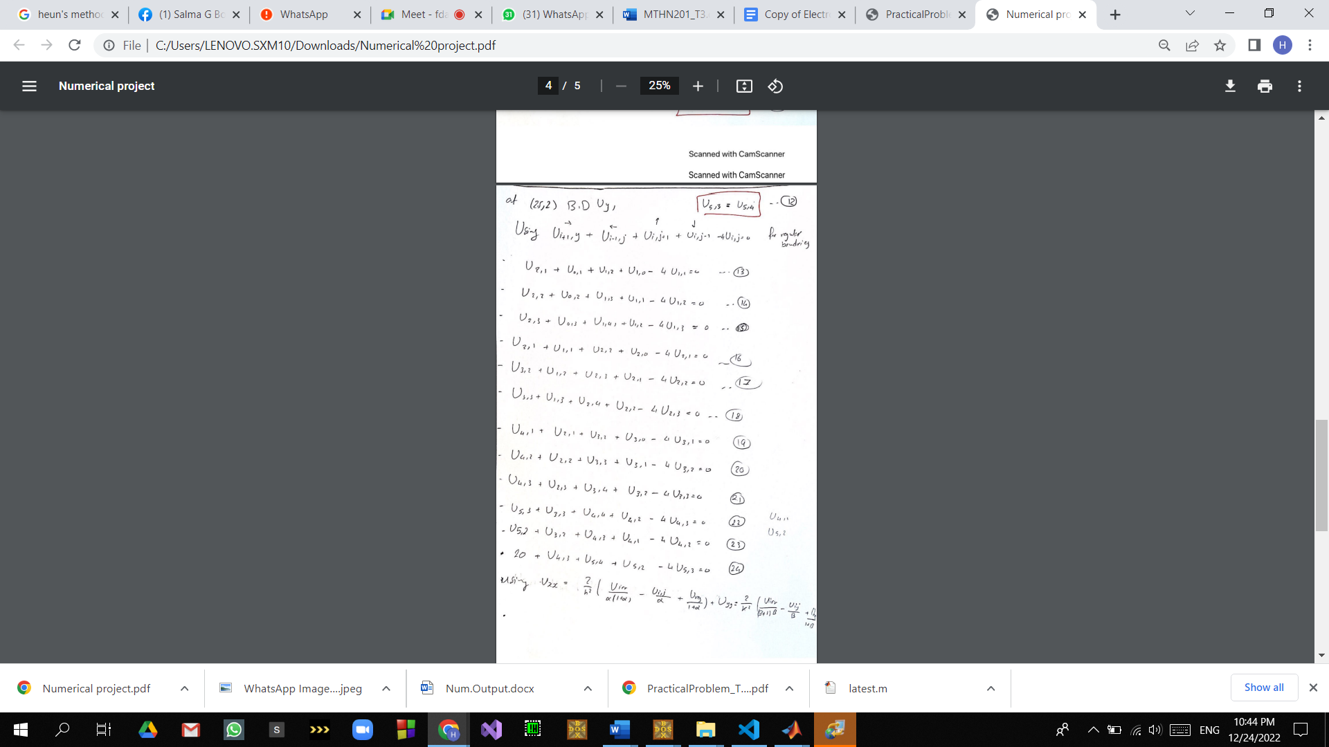



Matlab code FOR FD AND BD

%%%%%%%%%%%%%%%%% Question one Using FD , BD for some points

clc;

clear all;

close all;

syms U00 U01 U02 U03 U04 U10 U11 U12 U13 U14 U20 U21 U22 U23 U24 U30 U31 U32 U33 U34 U40 U42 U43 U44 U51 UIR52 UIR41 U53 U54 U41339 U0866

alpha=2-sqrt(3);

peta=alpha;

alpha1=alpha;

peta1=peta;

peta2=1-peta1;

alpha2=1-alpha1;

eq1=U01==U11-0.5;%%%%%%%%

eq2=U02==U12-0.5;%%%%%%%%

eq3=U03==U13-0.5;%%%%%%%%%

eq4=U10==U11;%%%%%%%%%%%%%

eq5=0==U21+U01+U10+U12-4*U11;

eq6=0==U02+U22+U13+U11-4*U12;

eq7=0==U23+U03+U14+U12-4*U13;

eq8=U14==U13;%%%%%%%%%

eq9=U20==U21;%%%%%%%%%%

eq10=0==U31+U11+U22+U20-4*U21;

eq11=0==U32+U12+U23+U21-4*U22;

eq12=0==U33+U13+U24+U22-4*U23;

eq13=U24==U23;%%%%%%%%%%%%

eq14=U30==U31;%%%%%%%%%

eq15=U40==(UIR41+U30)/2;%%%%%%%%%%%%%%

eq16=0==UIR41+U21+U32+U30-4*U31;

eq17=0==U42+U22+U33+U31-4*U32;

eq18=0==U43+U23+U34+U32-4*U33;

eq19=U34==U33;%%%%%%%%%%%%%%

eq20=0==2*((U41339/(alpha*(1+alpha)))-(UIR41/(alpha))+(U31/(1+alpha)))+(U42+U40-2*UIR41);

eq21=0==UIR52+U32+U43+UIR41-4*U42;

eq22=0==U53+U33+U44+U42-4*U43;

eq23=U44==U43;%%%%%%%%%%%%%%%%

eq24=U51==-(peta2/peta1)*(((peta1-peta2)/(peta1*peta2))*U0866-((peta2/peta1)*UIR52));

eq25=0==2*((U0866/(peta*(1+peta)))-(UIR52/(peta))+(U53/(1+peta)))+(20-2*UIR52+U42);%%%%%@U5,2

eq26=0==20+U43+U54+UIR52-4*U53;

eq27=U54==U53;%%%%%%%%%%

eq28=0==((alpha2/alpha1)*UIR41-((alpha1-alpha2)/(alpha2*alpha1))*U41339-(alpha1/alpha2)*U51);

eq29=0==((peta2/peta1)*UIR52-((peta1-peta2)/(peta2*peta1))*U0866-(peta1/peta2)*U51);

eq30=U04==(U03+U14-0.5)/2;%%%%%%%%

eq31=U00==(U01+U10-0.5)/2;%%%%%%%%%

[x,y]=equationsToMatrix([eq1,eq2,eq3,eq4,eq5,eq6,eq7,eq8,eq9,eq10,eq11,eq12,eq13,eq14,eq15,eq16,eq17,eq18,eq19,eq20,eq21,eq22,eq23,eq24,eq25,eq26,eq27,eq28,eq29,eq30,eq31]);

N=linsolve(x,y);

fprintf('%g\n',abs(N)*2.15)

Results:

0.513644

0.513644

0.870938

1.2381

1.2381

5.55922

1.58864

1.58864

1.94594

2.3131

2.3131

2.30635

2.30635

3.01107

3.75527

3.75527

2.31934

2.31934

4.0367

5.94164

5.94164

1.46715

0.710104

4.87476

10.033

10.033

0

19.2825

19.2825

0.614968

4.81443

From these results we can see the distribution of h on our grid which is reasonable as some of them are near to 20 which is the boundaries values.

AGAIN USING CD:

Hand analysis:



 



Results: NOTE THESE RESULTS ARE NOT ARRANGED

0.965819

1.06189

1.30904

1.56703

1.67551

2.74945

1.36975

1.48634

1.80363

2.14178

2.28399

1.54051

1.71009

2.27737

2.91245

3.17692

1.3721

1.53615

2.68331

4.05373

4.59877

0.875596

0.437737

2.86597

6.0204

7.11071

0

10.0512

11.8033

0.379092

2.38109

Code for matlab CD

%%%%%%%%%%%%%%%%% Question one Using FD , BD for some points

clc;

clear all;

close all;

syms U00 U01 U02 U03 U04 U10 U11 U12 U13 U14 U20 U21 U22 U23 U24 U30 U31 U32 U33 U34 U40 U42 U43 U44 U51 UIR52 UIR41 U53 U54 U41339 U0866

alpha=2-sqrt(3);

peta=alpha;

alpha1=alpha;

peta1=peta;

peta2=1-peta1;

alpha2=1-alpha1;

eq31=2*U10+2*U01-4*U00==1;%%%%%%%U00%%

eq32=U02+2*U11+U00-4*U01==1;%%%%%%%U01

eq33=U03+2*U12+U01-4*U02==1;%%%%%%%U02

eq34=U04+2*U13+U02-4*U03==1;%%%%%%%U03

eq30=2*U03+2*U14-4*U04==1;%%%%%%U04%%

eq1=2*U11+U20+U00-4*U10==0;%%%%%%%% U10

eq9=2*U21+U30+U10+-4*U20==0;%%%%%%%%%%%%% U20%%%%%%%

eq2=2*U31+U40+U20-4*U30==0;%%%%%%%% U30

eq15=2*UIR41+2*U30-4*U40==0;%%%%%%%%%%%%%%U40

eq5=U01+U21+U12+U10-4*U11==0; %%%%%%% U11

eq6=U02+U22+U13+U11-4*U12==0;%%%%%%%%% U12

eq7=U03+U23+U14+U12-4*U13==0;%%%%%%%% U13

eq3=2*U13+U24+U04-4*U14==0;%%%%%%%%% U14

eq10=U31+U11+U22+U20-4*U21==0;%%%%%%%% U21

eq11=U32+U12+U23+U21-4*U22==0;%%%% U22

eq12=U33+U13+U24+U22-4*U23==0;%%%%%%%%U23

eq13=2*U23+U34+U14+-4*U24==0;%%%%%%%%%% U24%%%%%%%%%%%%

eq16=UIR41+U21+U32+U30-4*U31==0;%%%%%%%%%%U31

eq17=U42+U22+U33+U31-4*U32==0;%%%%%%%%%%U32

eq18=U43+U23+U34+U32-4*U33==0;%%%%%%U33

eq19=2*U33+U44+U24+-4*U34==0;%%%%%%%%%%%%%%U34

eq20=2*((U41339/(alpha*(1+alpha)))-(UIR41/(alpha))+(U31/(1+alpha)))+(U42+U40-2*UIR41)==0;%%%%%%%U41

eq21=UIR52+U32+U43+UIR41-4*U42==0;%%%U42

eq22=U53+U33+U44+U42-4*U43==0;%%%%%%U43

eq23=2*U43+U54+U34+-4*U44==0;%%%%%%%%%%%%%%%%U44

eq24=-1*(peta2/peta1)*(((peta1-peta2)/(peta1*peta2))*U0866-((peta2/peta1)*UIR52))==U51;%%%%%%%%%%U51

eq25=2*((U0866/(peta*(1+peta)))-(UIR52/(peta))+(U53/(1+peta)))+(20-2*UIR52+U42)==0;%%%%%@U5,2

eq26=20+U43+U54+UIR52-4*U53==0;%%%%%%%%U53

eq27=2*U53+20+U44+-4*U54==0;%%%%%%%%%%U54

eq28=(alpha2/alpha1)*UIR41-((alpha1-alpha2)/(alpha2*alpha1))*U41339-(alpha1/alpha2)*U51==0;%%%%%%%%UIRALPHA

eq29=(peta2/peta1)*UIR52-((peta1-peta2)/(peta2*peta1))*U0866-(peta1/peta2)*U51==0;%%%%%%%%%UIRPETA

[x,y]=equationsToMatrix([eq1,eq2,eq3,eq5,eq6,eq7,eq9,eq10,eq11,eq12,eq13,eq15,eq16,eq17,eq18,eq19,eq20,eq21,eq22,eq23,eq24,eq25,eq26,eq27,eq28,eq29,eq30,eq31,eq32,eq33,eq34]);

N=linsolve(x,y);

fprintf('%g\n',abs(N))

# Problem 2

**Given *y*′′=-1001*z*-1000*y*,*y*(0)=1,*y*′(0)=0,*h*=0.002,*y*(5)=?  
  
put *dy/dx*=*z* and differentiate w.r.t. x, we obtain *d*2*y/dx*2=*dz/dx*  
  
We have system of equations  
*dydx*=*z*=*f*(*x*,*y*,*z*)  
  
*dzdx*=-1001*z*-1000*y*=*g*(*x*,*y*,*z*)  
  
Forth order R-K method for second order differential equation**

## Solution

**As we have step of 0.002 -> The needed number of iterations to reach exact solution**

**Is 2500**

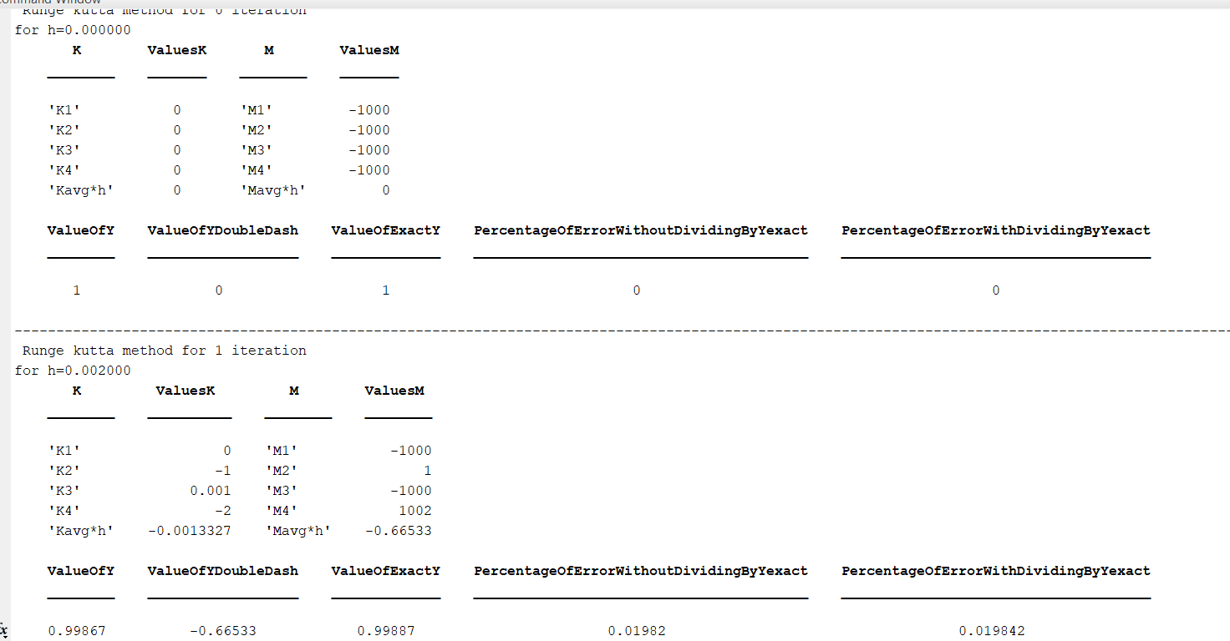The Final Iterations are shown in screenshots below These results :

Note: we can see here the difference when the step increases the error increases unlike the first one when h=0 the error=0.

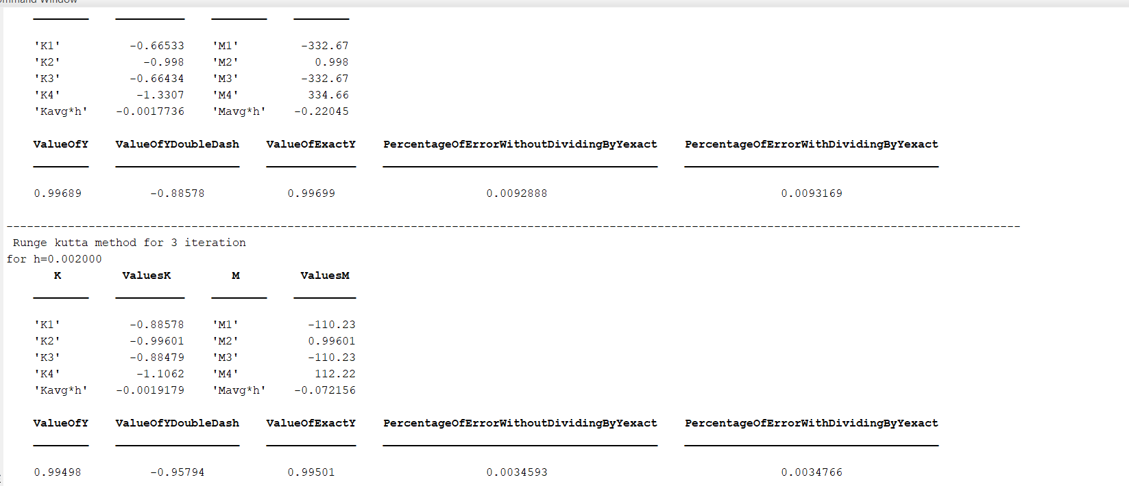  
Now,  
*y*1=*y*0+16(*k*1+2*k*2+2*k*3+*k*4)  
  
*y*1=1+16[0+2(-0.002)+2(0)+(-0.004)]  
  
*y*1=0.9987  
  
*z*1=*z*0+16(*m*1+2*m*2+2*m*3+*m*4)  
  
*z*1=0+16[-2+2(0.002)+2(-2)+(2.004)]  
  
*z*1=-0.6653  
  
∴*y*(0.002)=0.9987  
  
∴*y*′(0.002)=-0.6653

Again taking (*x*1,*y*1,*z*1) in place of (*x*0,*y*0,*z*0) and repeat the process  
  
*k*1=*hf*(*x*1,*y*1,*z*1)=(0.002)⋅*f*(0.002,0.9987,-0.6653)=(0.002)⋅(-0.6653)=-0.0013  
  
*m*1=*hg*(*x*1,*y*1,*z*1)=(0.002)⋅*g*(0.002,0.9987,-0.6653)=(0.002)⋅(-332.668)=-0.6653  
  
*k*2=*hf*(*x*1+*h*2,*y*1+*k*12,*z*1+*m*12)=(0.002)⋅*f*(0.003,0.998,-0.998)=(0.002)⋅(-0.998)=-0.002  
  
*m*2=*hg*(*x*1+*h*2,*y*1+*k*12,*z*1+*m*12)=(0.002)⋅*g*(0.003,0.998,-0.998)=(0.002)⋅(0.998)=0.002  
  
*k*3=*hf*(*x*1+*h*2,*y*1+*k*22,*z*1+*m*22)=(0.002)⋅*f*(0.003,0.9977,-0.6643)=(0.002)⋅(-0.6643)=-0.0013  
  
*m*3=*hg*(*x*1+*h*2,*y*1+*k*22,*z*1+*m*22)=(0.002)⋅*g*(0.003,0.9977,-0.6643)=(0.002)⋅(-332.669)=-0.6653  
  
*k*4=*hf*(*x*1+*h*,*y*1+*k*3,*z*1+*m*3)=(0.002)⋅*f*(0.004,0.9973,-1.3307)=(0.002)⋅(-1.3307)=-0.0027  
  
*m*4=*hg*(*x*1+*h*,*y*1+*k*3,*z*1+*m*3)=(0.002)⋅*g*(0.004,0.9973,-1.3307)=(0.002)⋅(334.664)=0.6693  
  
Now,  
*y*2=*y*1+16(*k*1+2*k*2+2*k*3+*k*4)  
  
*y*2=0.9987+16[-0.0013+2(-0.002)+2(-0.0013)+(-0.0027)]  
  
*y*2=0.9969  
  
*z*2=*z*1+16(*m*1+2*m*2+2*m*3+*m*4)  
  
*z*2=-0.6653+16[-0.6653+2(0.002)+2(-0.6653)+(0.6693)]  
  
*z*2=-0.8858  
  
∴*y*(0.004)=0.9969  
  
∴*y*′(0.004)=-0.8858

Again taking (*x*2,*y*2,*z*2) in pmace of (*x*0,*y*0,*z*0) and repeat the process  
  
*k*1=*hf*(*x*2,*y*2,*z*2)=(0.002)⋅*f*(0.004,0.9969,-0.8858)=(0.002)⋅(-0.8858)=-0.0018  
  
*m*1=*hg*(*x*2,*y*2,*z*2)=(0.002)⋅*g*(0.004,0.9969,-0.8858)=(0.002)⋅(-110.2253)=-0.2205  
  
*k*2=*hf*(*x*2+*h*2,*y*2+*k*12,*z*2+*m*12)=(0.002)⋅*f*(0.005,0.996,-0.996)=(0.002)⋅(-0.996)=-0.002  
  
*m*2=*hg*(*x*2+*h*2,*y*2+*k*12,*z*2+*m*12)=(0.002)⋅*g*(0.005,0.996,-0.996)=(0.002)⋅(0.996)=0.002  
  
*k*3=*hf*(*x*2+*h*2,*y*2+*k*22,*z*2+*m*22)=(0.002)⋅*f*(0.005,0.9959,-0.8848)=(0.002)⋅(-0.8848)=-0.0018  
  
*m*3=*hg*(*x*2+*h*2,*y*2+*k*22,*z*2+*m*22)=(0.002)⋅*g*(0.005,0.9959,-0.8848)=(0.002)⋅(-110.2263)=-0.2205  
  
*k*4=*hf*(*x*2+*h*,*y*2+*k*3,*z*2+*m*3)=(0.002)⋅*f*(0.006,0.9951,-1.1062)=(0.002)⋅(-1.1062)=-0.0022  
  
*m*4=*hg*(*x*2+*h*,*y*2+*k*3,*z*2+*m*3)=(0.002)⋅*g*(0.006,0.9951,-1.1062)=(0.002)⋅(112.2173)=0.2244  
  
Now,  
*y*3=*y*2+16(*k*1+2*k*2+2*k*3+*k*4)  
  
*y*3=0.9969+16[-0.0018+2(-0.002)+2(-0.0018)+(-0.0022)]  
  
*y*3=0.995  
  
*z*3=*z*2+16(*m*1+2*m*2+2*m*3+*m*4)  
  
*z*3=-0.8858+16[-0.2205+2(0.002)+2(-0.2205)+(0.2244)]  
  
*z*3=-0.9579  
  
∴*y*(0.006)=0.995  
  
∴*y*′(0.006)=-0.9579

Again taking (*x*3,*y*3,*z*3) in place of (*x*0,*y*0,*z*0) and repeat the process  
  
*k*1=*hf*(*x*3,*y*3,*z*3)=(0.002)⋅*f*(0.006,0.995,-0.9579)=(0.002)⋅(-0.9579)=-0.0019  
  
*m*1=*hg*(*x*3,*y*3,*z*3)=(0.002)⋅*g*(0.006,0.995,-0.9579)=(0.002)⋅(-36.0791)=-0.0722  
  
*k*2=*hf*(*x*3+*h*2,*y*3+*k*12,*z*3+*m*12)=(0.002)⋅*f*(0.007,0.994,-0.994)=(0.002)⋅(-0.994)=-0.002  
  
*m*2=*hg*(*x*3+*h*2,*y*3+*k*12,*z*3+*m*12)=(0.002)⋅*g*(0.007,0.994,-0.994)=(0.002)⋅(0.994)=0.002  
  
*k*3=*hf*(*x*3+*h*2,*y*3+*k*22,*z*3+*m*22)=(0.002)⋅*f*(0.007,0.994,-0.9569)=(0.002)⋅(-0.9569)=-0.0019  
  
*m*3=*hg*(*x*3+*h*2,*y*3+*k*22,*z*3+*m*22)=(0.002)⋅*g*(0.007,0.994,-0.9569)=(0.002)⋅(-36.0801)=-0.0722  
  
*k*4=*hf*(*x*3+*h*,*y*3+*k*3,*z*3+*m*3)=(0.002)⋅*f*(0.008,0.9931,-1.0301)=(0.002)⋅(-1.0301)=-0.0021  
  
*m*4=*hg*(*x*3+*h*,*y*3+*k*3,*z*3+*m*3)=(0.002)⋅*g*(0.008,0.9931,-1.0301)=(0.002)⋅(38.0671)=0.0761  
  
Now,  
*y*4=*y*3+16(*k*1+2*k*2+2*k*3+*k*4)  
  
*y*4=0.995+16[-0.0019+2(-0.002)+2(-0.0019)+(-0.0021)]  
  
*y*4=0.993  
  
*z*4=*z*3+16(*m*1+2*m*2+2*m*3+*m*4)  
  
*z*4=-0.9579+16[-0.0722+2(0.002)+2(-0.0722)+(0.0761)]  
  
*z*4=-0.9807  
  
∴*y*(0.008)=0.993  
  
∴*y*′(0.008)=-0.9807

Again taking (*x*4,*y*4,*z*4) in place of (*x*0,*y*0,*z*0) and repeat the process  
  
*k*1=*hf*(*x*4,*y*4,*z*4)=(0.002)⋅*f*(0.008,0.993,-0.9807)=(0.002)⋅(-0.9807)=-0.002  
  
*m*1=*hg*(*x*4,*y*4,*z*4)=(0.002)⋅*g*(0.008,0.993,-0.9807)=(0.002)⋅(-11.365)=-0.0227  
  
*k*2=*hf*(*x*4+*h*2,*y*4+*k*12,*z*4+*m*12)=(0.002)⋅*f*(0.009,0.992,-0.992)=(0.002)⋅(-0.992)=-0.002  
  
*m*2=*hg*(*x*4+*h*2,*y*4+*k*12,*z*4+*m*12)=(0.002)⋅*g*(0.009,0.992,-0.992)=(0.002)⋅(0.992)=0.002  
  
*k*3=*hf*(*x*4+*h*2,*y*4+*k*22,*z*4+*m*22)=(0.002)⋅*f*(0.009,0.992,-0.9797)=(0.002)⋅(-0.9797)=-0.002  
  
*m*3=*hg*(*x*4+*h*2,*y*4+*k*22,*z*4+*m*22)=(0.002)⋅*g*(0.009,0.992,-0.9797)=(0.002)⋅(-11.366)=-0.0227  
  
*k*4=*hf*(*x*4+*h*,*y*4+*k*3,*z*4+*m*3)=(0.002)⋅*f*(0.01,0.9911,-1.0034)=(0.002)⋅(-1.0034)=-0.002  
  
*m*4=*hg*(*x*4+*h*,*y*4+*k*3,*z*4+*m*3)=(0.002)⋅*g*(0.01,0.9911,-1.0034)=(0.002)⋅(13.3491)=0.0267  
  
Now,  
*y*5=*y*4+16(*k*1+2*k*2+2*k*3+*k*4)  
  
*y*5=0.993+16[-0.002+2(-0.002)+2(-0.002)+(-0.002)]  
  
*y*5=0.991  
  
*z*5=*z*4+16(*m*1+2*m*2+2*m*3+*m*4)  
  
*z*5=-0.9807+16[-0.0227+2(0.002)+2(-0.0227)+(0.0267)]  
  
*z*5=-0.9869  
  
∴*y*(0.01)=0.991  
  
∴*y*′(0.01)=-0.9869

Again taking (*x*5,*y*5,*z*5) in place of (*x*0,*y*0,*z*0) and repeat the process  
  
*k*1=*hf*(*x*5,*y*5,*z*5)=(0.002)⋅*f*(0.01,0.991,-0.9869)=(0.002)⋅(-0.9869)=-0.002  
  
*m*1=*hg*(*x*5,*y*5,*z*5)=(0.002)⋅*g*(0.01,0.991,-0.9869)=(0.002)⋅(-3.1283)=-0.0063  
  
*k*2=*hf*(*x*5+*h*2,*y*5+*k*12,*z*5+*m*12)=(0.002)⋅*f*(0.011,0.99,-0.99)=(0.002)⋅(-0.99)=-0.002  
  
*m*2=*hg*(*x*5+*h*2,*y*5+*k*12,*z*5+*m*12)=(0.002)⋅*g*(0.011,0.99,-0.99)=(0.002)⋅(0.99)=0.002  
  
*k*3=*hf*(*x*5+*h*2,*y*5+*k*22,*z*5+*m*22)=(0.002)⋅*f*(0.011,0.99,-0.9859)=(0.002)⋅(-0.9859)=-0.002  
  
*m*3=*hg*(*x*5+*h*2,*y*5+*k*22,*z*5+*m*22)=(0.002)⋅*g*(0.011,0.99,-0.9859)=(0.002)⋅(-3.1293)=-0.0063  
  
*k*4=*hf*(*x*5+*h*,*y*5+*k*3,*z*5+*m*3)=(0.002)⋅*f*(0.012,0.9891,-0.9932)=(0.002)⋅(-0.9932)=-0.002  
  
*m*4=*hg*(*x*5+*h*,*y*5+*k*3,*z*5+*m*3)=(0.002)⋅*g*(0.012,0.9891,-0.9932)=(0.002)⋅(5.1084)=0.0102  
  
Now,  
*y*6=*y*5+16(*k*1+2*k*2+2*k*3+*k*4)  
  
*y*6=0.991+16[-0.002+2(-0.002)+2(-0.002)+(-0.002)]  
  
*y*6=0.9891  
  
*z*6=*z*5+16(*m*1+2*m*2+2*m*3+*m*4)  
  
*z*6=-0.9869+16[-0.0063+2(0.002)+2(-0.0063)+(0.0102)]  
  
*z*6=-0.9877  
  
∴*y*(0.012)=0.9891  
  
∴*y*′(0.012)=-0.9877

Again taking (*x*6,*y*6,*z*6) in place of (*x*0,*y*0,*z*0) and repeat the process  
  
*k*1=-0.002,*k*2=-0.002,*k*3=-0.002,*k*4=-0.002,*y*7=0.9871  
  
*m*1=-0.0008,*m*2=0.002,*m*3=-0.0008,*m*4=0.0047,*z*7=-0.9866  
  
∴*y*(0.014)=0.9871  
  
∴*y*′(0.014)=-0.9866

*k*1=-0.002,*k*2=-0.002,*k*3=-0.002,*k*4=-0.002,*y*8=0.9851  
  
*m*1=0.0011,*m*2=0.002,*m*3=0.0011,*m*4=0.0029,*z*8=-0.985  
  
∴*y*(0.016)=0.9851  
  
∴*y*′(0.016)=-0.985

*k*1=-0.002,*k*2=-0.002,*k*3=-0.002,*k*4=-0.002,*y*9=0.9831  
  
*m*1=0.0017,*m*2=0.002,*m*3=0.0017,*m*4=0.0023,*z*9=-0.9831  
  
∴*y*(0.018)=0.9831  
  
∴*y*′(0.018)=-0.9831

*k*1=-0.002,*k*2=-0.002,*k*3=-0.002,*k*4=-0.002,*y*10=0.9812  
  
*m*1=0.0019,*m*2=0.002,*m*3=0.0019,*m*4=0.0021,*z*10=-0.9812  
  
∴*y*(0.02)=0.9812  
  
∴*y*′(0.02)=-0.9812

*k*1=-0.002,*k*2=-0.002,*k*3=-0.002,*k*4=-0.002,*y*11=0.9792  
  
*m*1=0.0019,*m*2=0.002,*m*3=0.0019,*m*4=0.002,*z*11=-0.9792  
  
∴*y*(0.022)=0.9792  
  
∴*y*′(0.022)=-0.9792

*k*1=-0.002,*k*2=-0.002,*k*3=-0.002,*k*4=-0.002,*y*12=0.9773  
  
*m*1=0.0019,*m*2=0.002,*m*3=0.0019,*m*4=0.002,*z*12=-0.9773  
  
∴*y*(0.024)=0.9773  
  
∴*y*′(0.024)=-0.9773

*k*1=-0.002,*k*2=-0.002,*k*3=-0.002,*k*4=-0.002,*y*13=0.9753  
  
*m*1=0.002,*m*2=0.002,*m*3=0.0019,*m*4=0.002,*z*13=-0.9753  
  
∴*y*(0.026)=0.9753  
  
∴*y*′(0.026)=-0.9753

*k*1=-0.002,*k*2=-0.0019,*k*3=-0.0019,*k*4=-0.0019,*y*14=0.9734  
  
*m*1=0.0019,*m*2=0.0019,*m*3=0.0019,*m*4=0.0019,*z*14=-0.9734  
  
∴*y*(0.028)=0.9734  
  
∴*y*′(0.028)=-0.9734

*k*1=-0.0019,*k*2=-0.0019,*k*3=-0.0019,*k*4=-0.0019,*y*15=0.9714  
  
*m*1=0.0019,*m*2=0.0019,*m*3=0.0019,*m*4=0.0019,*z*15=-0.9714  
  
∴*y*(0.03)=0.9714  
  
∴*y*′(0.03)=-0.9714

*k*1=-0.0019,*k*2=-0.0019,*k*3=-0.0019,*k*4=-0.0019,*y*16=0.9695  
  
*m*1=0.0019,*m*2=0.0019,*m*3=0.0019,*m*4=0.0019,*z*16=-0.9695  
  
∴*y*(0.032)=0.9695  
  
∴*y*′(0.032)=-0.9695

*k*1=-0.0019,*k*2=-0.0019,*k*3=-0.0019,*k*4=-0.0019,*y*17=0.9675  
  
*m*1=0.0019,*m*2=0.0019,*m*3=0.0019,*m*4=0.0019,*z*17=-0.9675  
  
∴*y*(0.034)=0.9675  
  
∴*y*′(0.034)=-0.9675

*k*1=-0.0019,*k*2=-0.0019,*k*3=-0.0019,*k*4=-0.0019,*y*18=0.9656  
  
*m*1=0.0019,*m*2=0.0019,*m*3=0.0019,*m*4=0.0019,*z*18=-0.9656  
  
∴*y*(0.036)=0.9656  
  
∴*y*′(0.036)=-0.9656

*k*1=-0.0019,*k*2=-0.0019,*k*3=-0.0019,*k*4=-0.0019,*y*19=0.9637  
  
*m*1=0.0019,*m*2=0.0019,*m*3=0.0019,*m*4=0.0019,*z*19=-0.9637  
  
∴*y*(0.038)=0.9637  
  
∴*y*′(0.038)=-0.9637

*k*1=-0.0019,*k*2=-0.0019,*k*3=-0.0019,*k*4=-0.0019,*y*20=0.9618  
  
*m*1=0.0019,*m*2=0.0019,*m*3=0.0019,*m*4=0.0019,*z*20=-0.9618  
  
∴*y*(0.04)=0.9618  
  
∴*y*′(0.04)=-0.9618

*k*1=-0.0019,*k*2=-0.0019,*k*3=-0.0019,*k*4=-0.0019,*y*21=0.9598  
  
*m*1=0.0019,*m*2=0.0019,*m*3=0.0019,*m*4=0.0019,*z*21=-0.9598  
  
∴*y*(0.042)=0.9598  
  
∴*y*′(0.042)=-0.9598

*k*1=-0.0019,*k*2=-0.0019,*k*3=-0.0019,*k*4=-0.0019,*y*22=0.9579  
  
*m*1=0.0019,*m*2=0.0019,*m*3=0.0019,*m*4=0.0019,*z*22=-0.9579  
  
∴*y*(0.044)=0.9579  
  
∴*y*′(0.044)=-0.9579

*k*1=-0.0019,*k*2=-0.0019,*k*3=-0.0019,*k*4=-0.0019,*y*23=0.956  
  
*m*1=0.0019,*m*2=0.0019,*m*3=0.0019,*m*4=0.0019,*z*23=-0.956  
  
∴*y*(0.046)=0.956  
  
∴*y*′(0.046)=-0.956

*k*1=-0.0019,*k*2=-0.0019,*k*3=-0.0019,*k*4=-0.0019,*y*24=0.9541  
  
*m*1=0.0019,*m*2=0.0019,*m*3=0.0019,*m*4=0.0019,*z*24=-0.9541  
  
∴*y*(0.048)=0.9541  
  
∴*y*′(0.048)=-0.9541

*k*1=-0.0019,*k*2=-0.0019,*k*3=-0.0019,*k*4=-0.0019,*y*25=0.9522  
  
*m*1=0.0019,*m*2=0.0019,*m*3=0.0019,*m*4=0.0019,*z*25=-0.9522  
  
∴*y*(0.05)=0.9522  
  
∴*y*′(0.05)=-0.9522

*k*1=-0.0019,*k*2=-0.0019,*k*3=-0.0019,*k*4=-0.0019,*y*26=0.9503  
  
*m*1=0.0019,*m*2=0.0019,*m*3=0.0019,*m*4=0.0019,*z*26=-0.9503  
  
∴*y*(0.052)=0.9503  
  
∴*y*′(0.052)=-0.9503

*k*1=-0.0019,*k*2=-0.0019,*k*3=-0.0019,*k*4=-0.0019,*y*27=0.9484  
  
*m*1=0.0019,*m*2=0.0019,*m*3=0.0019,*m*4=0.0019,*z*27=-0.9484  
  
∴*y*(0.054)=0.9484  
  
∴*y*′(0.054)=-0.9484

*k*1=-0.0019,*k*2=-0.0019,*k*3=-0.0019,*k*4=-0.0019,*y*28=0.9465  
  
*m*1=0.0019,*m*2=0.0019,*m*3=0.0019,*m*4=0.0019,*z*28=-0.9465  
  
∴*y*(0.056)=0.9465  
∴*y*′(0.056)=-0.9465

*k*1=-0.0019,*k*2=-0.0019,*k*3=-0.0019,*k*4=-0.0019,*y*29=0.9446  
  
*m*1=0.0019,*m*2=0.0019,*m*3=0.0019,*m*4=0.0019,*z*29=-0.9446  
  
∴*y*(0.058)=0.9446  
  
∴*y*′(0.058)=-0.9446

**Some of The last iterations From screenshots :**

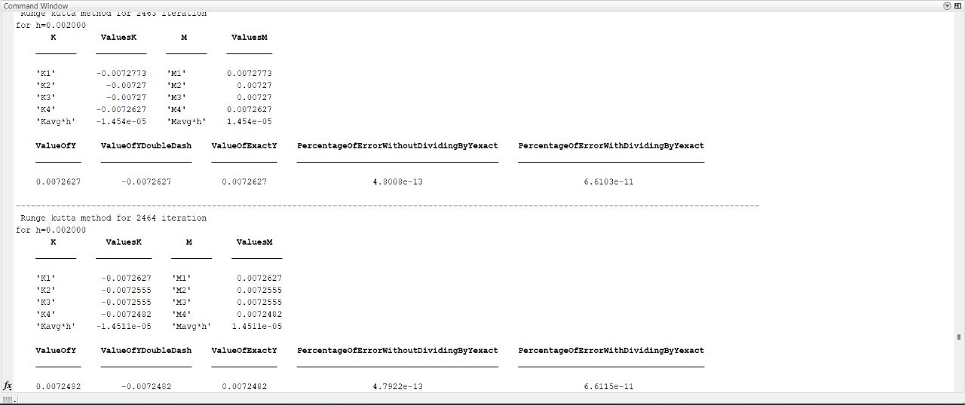

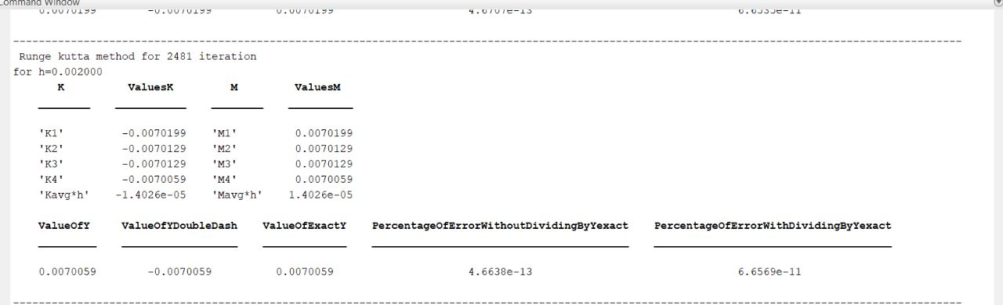

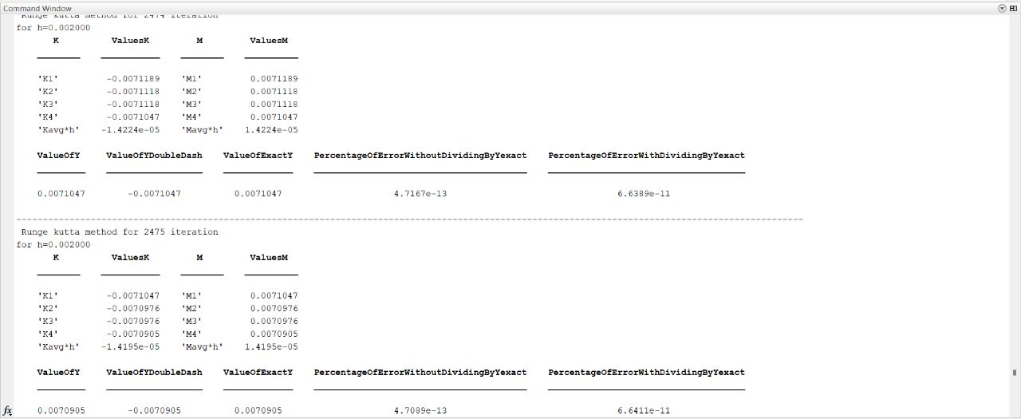





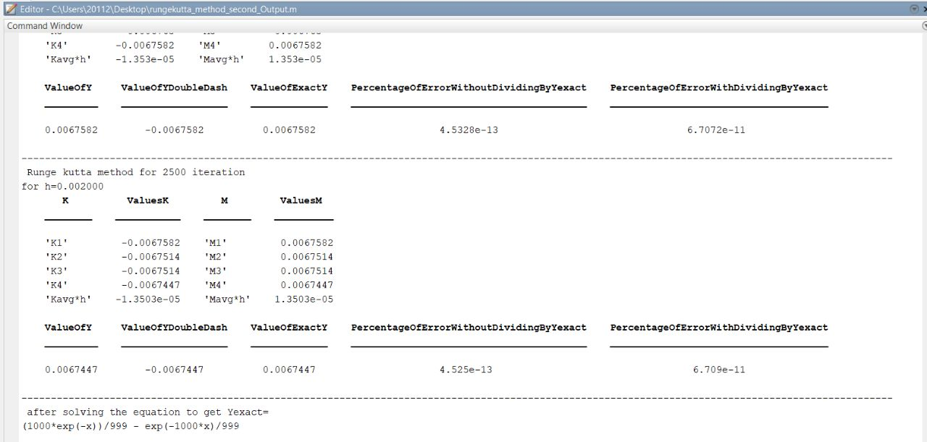

**THE REASON FOR THE INCRIDIBLE ERROR:**

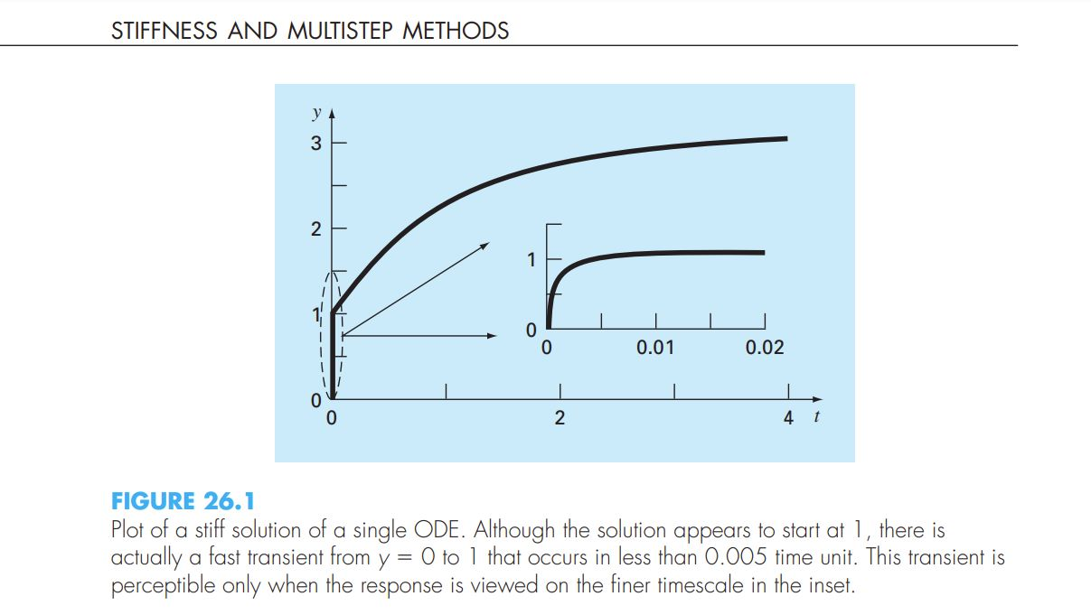

Stiffness is a special problem that can arise in the solution of ordinary differential equations. A stiff system involves rapidly changing components and slowly

changing ones. In many cases, the rapidly varying components are ephemeral transients

that die away quickly, after which the solution becomes dominated by the slowly varying

components. Although the transient phenomena exist for only a short part of the integration interval, they can dictate the time step for the entire solution.

In [mathematics](https://en.wikipedia.org/wiki/Mathematics), a stiff equation is a [differential equation](https://en.wikipedia.org/wiki/Differential_equation) for which certain [numerical methods](https://en.wikipedia.org/wiki/Numerical_ordinary_differential_equations) for solving the equation are [numerically unstable](https://en.wikipedia.org/wiki/Numerical_stability) unless the step size is taken to be extremely small. It has proven difficult to formulate a precise definition of stiffness, but the main idea is that the equation includes some terms that can lead to rapid variation in the solution.

When integrating a differential equation numerically, one would expect the requisite step size to be relatively small in a region where the [solution curve](https://en.wikipedia.org/wiki/Solution_curve) displays many variations and to be relatively large where the solution curve straightens out to approach a line with a slope of nearly zero. For some problems, this is not the case. For a numerical method to give a reliable solution to the differential system sometimes the step size is required to be at an unacceptably small level in a region where the solution curve is very smooth. The phenomenon is known as *stiffness*. In some cases, there may be two different problems with the same solution, yet one is not stiff and the other is. The phenomenon cannot, therefore, be a property of the exact solution, since this is the same for both problems, and must be a property of the differential system itself. Such systems are thus known as *stiff systems*.

As in Fig. 26.1, the solution is initially dominated by the fast exponential term

(e21000t). After a short period (t , 0.005), this transient dies out and the solution becomes

dictated by the slow exponential (e2t).44

If y(0) 5 0, the analytical solution can be developed as

y 5 3 2 0.998e21000t 2 2.002e2t (26.2)

 As in Fig. 26.1, the solution is initially dominated by the fast exponential term

(e21000t). After a short period (t , 0.005), this transient dies out and the solution becomes

dictated by the slow exponential (e2t).

## Conclusions and comparing results

1. The error increases significantly with the increase in step sizes , for example when we used h=0.2 the results were as follows:

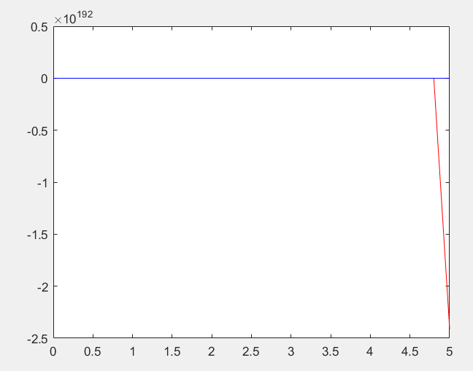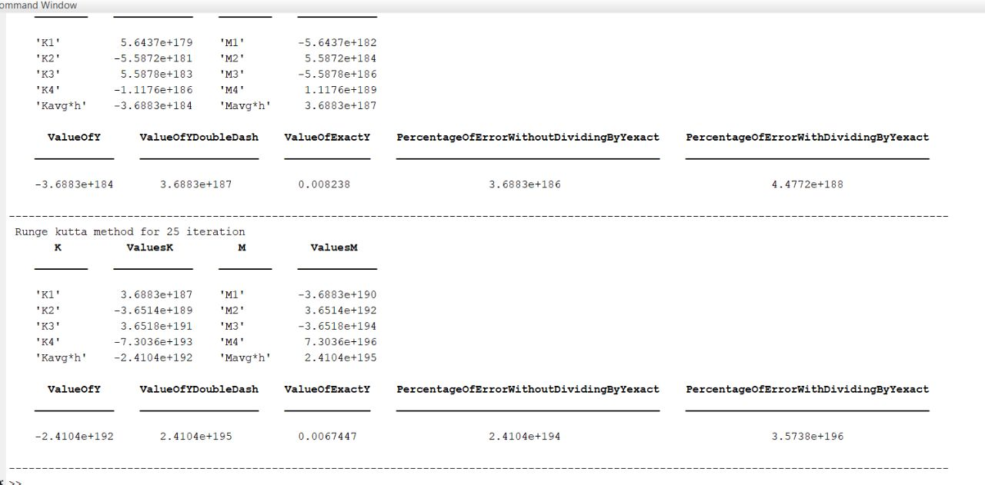

It seems that the error was x10^192

1. But when we estimated the results using smaller step sizes , the Yexact solution and the predicted Ones became nearly the same as shown in the following graphs :

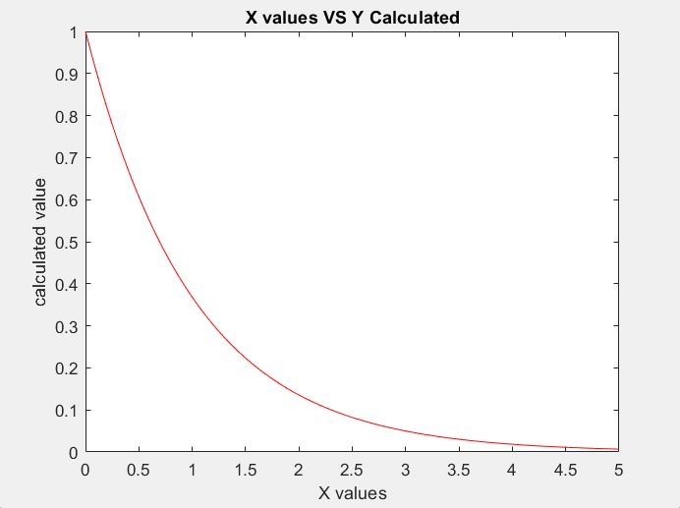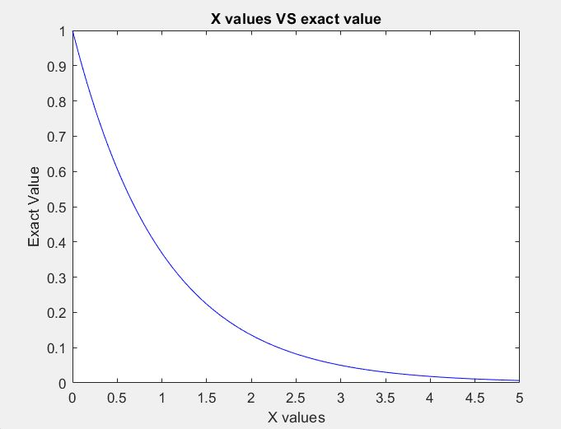

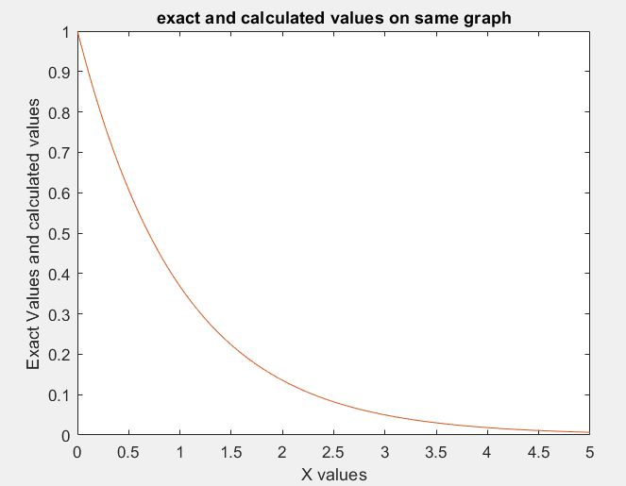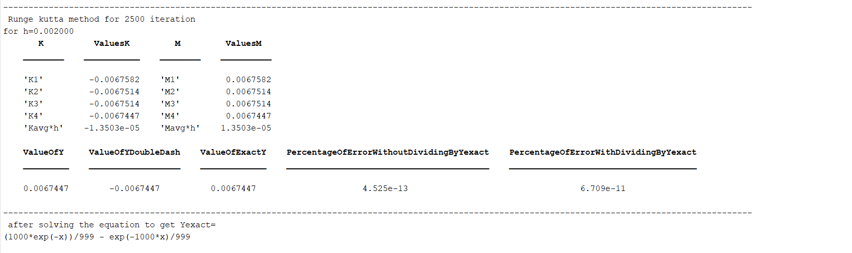

## Matlab Code

%% a) Solve this differential equation Numerically using Runge-Kutta’s method for x = 0 to 5 with a step size of 0.002.

%% Note that the initial conditions are y(0)=1 and y’(0)=0.

%%c) Compare and comment.

%%%%%%%%%%%%%%%%%%%%%%%%%%%%%%%%%%if we are dealing with each value of x as if it is the X0 with new h greater than the old one with 0.002%%%%%%%%%%%%%%%%%%%%%%%%%%

function rungekutta_method

% calculates the numerical values of second order ODE using RK

% you have to enter equations of z and y double dash at the end of this file

% you have to enter intial conditions at the beginings of file

clc % clears the command window

clc % clears the command window

clear % clears the workspace

x0=0; % xn value

y0=1; % yn value

z0=0; % y'n value

counter=1;

n=1;

for i=0:0.002:5

    H(n)=i;

end

for x1=0:0.002:5

    yexact(counter)=(1/999)*(1000*exp((-x1))-exp((-1000*x1)));

    h=x1-x0;

    H(counter)=h;

    k1=ydash(z0);% F( Zn )

    m1=zdash(y0,z0); % G( Yn , Zn )

    k2=ydash(z0+(m1*(h/2)));% F(Zn +(m1×h/2))

    m2=zdash(y0+(k1*(h/2)),z0+(m1*h/2));% G(Yn +(k1×h/2),Zn +(m1×h/2))

    k3=ydash(z0+(m2*(h/2))); % G(Yn +(k2×h/2), Zn +(m2×h/2))

    m3=zdash(y0+(k2*h/2),z0+(m2*(h/2)));% G(Yn +(k2×h/2), Zn +(m2×h/2))

    k4=ydash(z0+m3*h); % F(Yn +(k3×h), Zn +(m3×h))

    m4=zdash(y0+k3*h,z0+m3*h);% G(Yn +(k3×h), Zn +(m3×h))

    h_kavg=(h/6)*(k1+2*k2+2*k3+k4);

    h_mavg=(h/6)*(m1+2*m2+2*m3+m4);

    y1(counter)=y0+h_kavg;

    z1=z0+h_mavg;

    z0=z1;

    x0=x1;

    y0=y1(counter);

    fprintf(' Runge kutta method for %d iteration \n',counter-1);

    fprintf('for h=%f \n',h)

    K={'K1';'K2';'K3';'K4';'Kavg*h'};

    ValuesK=[k1;k2;k3;k4;h_kavg];

    M={'M1';'M2';'M3';'M4';'Mavg*h'};

    ValuesM=[m1;m2;m3;m4;h_mavg];

    ValueOfY=y1(counter);

    ValueOfYDoubleDash=z1;

    ValueOfExactY=yexact(counter);

    t=table(K,ValuesK,M,ValuesM);

    disp(t);

    erroryWith=(abs((y1(counter)-yexact(counter))/yexact(counter)))*100;

    erroryWithout=(abs((y1(counter)-yexact(counter))))*100;

    error(counter)=erroryWith;

    % disp('THE ERROR PERCENTAGE=');

    % fprintf('%10.2e %% \n',errory);

    counter=counter+1;

    PercentageOfErrorWithoutDividingByYexact=erroryWithout;

    PercentageOfErrorWithDividingByYexact=erroryWith;

    c=table(ValueOfY,ValueOfYDoubleDash,ValueOfExactY,PercentageOfErrorWithoutDividingByYexact,PercentageOfErrorWithDividingByYexact);

    disp(c);

    disp('----------------------------------------------------------------------------------------------------------------------------------------------------')

end

n=1;

for i=0:0.002:5

    x1(n)=i;

    n=n+1;

end

figure

plot(x1,yexact,x1,y1)

title('exact and calculated values on same graph');

xlabel('X values');

ylabel('Exact Values and calculated values');

figure

plot(x1,yexact,'b')

title('X values VS exact value');

xlabel('X values');

ylabel('Exact Value');

figure

plot(x1,y1,'r')

title('X values VS Y Calculated');

xlabel('X values');

ylabel('calculated value');

figure

plot(error,H)

title('step size VS error');

xlabel('Error');

ylabel('Step Size');

syms y(x)

Dy = diff(y);

ode = diff(y,x,2) == -1001*Dy-1000*y;

cond1 = y(0) ==1;

cond2 = Dy(0) == 0;

Yexact=dsolve(ode,cond1,cond2);

fprintf(' after solving the equation to get Yexact=\n');

disp(Yexact);

function f=ydash(z)

% enter the equation of y' here

f=z;

function g=zdash(y,z)

% enter the equation of z' here

g=-1001*z-1000*y